OCEAN COUNTING
By Janet Lawler

Curriculum/Parent Guide
[relevant Common Core Standards are noted]

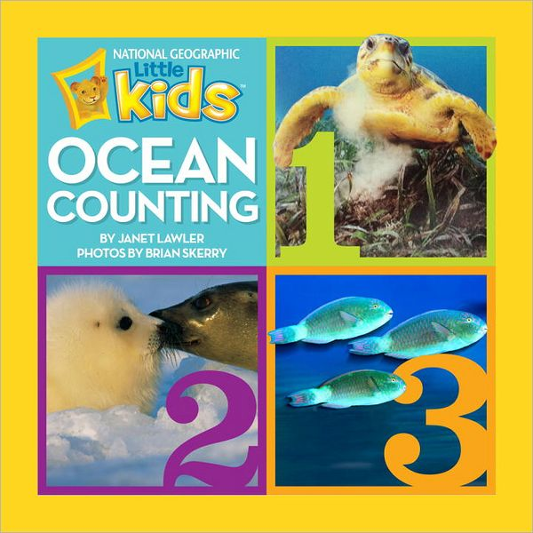

ABOUT THE BOOK
This non-fiction counting book combines vibrant color photographs of ocean animals and simple, informative text to teach children to count and better understand sea life. Ocean Counting can serve as an enjoyable and informative read-aloud and/or as a tool for developing literacy (reading and writing) and math skills. These skills can be developed in the context of science curriculum content (organisms; habitats; life cycles; prey/predator; feeding; reproduction). Below are some suggested approaches for sharing/teaching this book.

FOUNDATIONAL SKILLS
Text provides many opportunities for understanding: print; spoken words, syllables, and sounds; phonics awareness; and vocabulary in context. A brief glossary defines new words.
[ELA.RF.K1–4; ELA.RF.1.1–1.4]

PRE-READING DISCUSSION
Show and read book cover.
What is this book about? What are the main topics?
Identify author and photographer and discuss their roles.
Share back cover and title page.
[ELA.RI.K.2; ELA.RI.K.5–6]

INTRODUCTION
Read introduction and the Did You Know? additional information on left page.
Discuss in grade-appropriate manner the very large number of animals that live in the ocean (for older children, explain that a thousand is 100 “10s”).
[Math.1.NBT.B.2a]

SUGGESTED APPROACH TO TEXT

Content Comprehension
For each number/animal (1 to 10), read main text paragraph, pausing after questions to discuss and have children volunteer possible answers. Discuss text and photographs. Have students ask and answer questions about topic.
[ELA.RI.K.1; ELA.RI.1.1]

If children want more information about animal, turn to Animal Facts and read pertinent box.

Photos and Text as Separate Sources of information
In addition to reading text as recommended above, discuss how information can be conveyed by both photos and text; for example:

1 green sea turtle

Talk about how a photograph captures a moment in time and conveys certain information. Point out how studying a photograph can give you more facts.

Discuss relationship between this text and photo. Look closely at the photo. Can you see the bit of sea grass hanging from the turtle’s mouth? The turtle has just taken a big bite. The “puff of smoke” is the sandy sea bottom stirred up when the turtle pulled out the grass by its roots. Both the photo and the text tell you about what and how this turtle is eating.

The Did You Know? information provides an interesting fact that is not shown or found in the photo. (“Green sea turtles often swim hundreds of miles to lay eggs on the same beach where they were born.”)
[ELA.RI.K.7; ELA.RI.1.6]

New Words and Glossary
For each spread, discuss any unfamiliar words, introducing use of glossary, where appropriate; for example:

3 parrot fish

Did You Know? information includes the word “mucus.”

Ask child/students if they know what mucus is. Discuss. Turn to glossary on final page. Explain what a glossary is. Read definition of mucus.
[ELA.RI.K.4; ELA.RI.1.5]

Basic Counting
Point to each animal in photo and count together with children (one sea turtle, one; two harp seals, one, two; three parrotfish, one, two, three; etc.)
[Math.K.CC.B.4a]

Order of Counted Objects
On multiple reads, point in different order (or have student point) to show that the number of animals is same regardless of arrangement or order in which they are counted. [Math.K.CC.B.4b]

SUMMARY COUNTING CHART

Counting Up and Down to 10
Lead child or class, in unison, reading the counting chart out loud, counting from 1 up to 10 and then down from 10 to 1. Point to each row as counting takes place. [Math.K.CC.B.4c; Math.K.CC.B.5]

One-to-One Correspondence
Alternatively, or on second read, adult should say, “Five pink sea stars,” as a child points and counts out loud: one, two, three, four, five, etc.). [Math.K.CC.B.4a;]

ANIMAL FACTS

New Words and Glossary
Discuss categories of information (Home, Size, Food, Predators, and Babies). Read fact boxes not already read and refer to glossary as necessary. [ELA.RI.K.4; ELA.RI.1.5]

Measurement and Size Concepts
Present/discuss basic measurements for Size category (such as length, height and weight). These are different ways to compare two objects or animals.

Read some or all of Animal fact boxes. Focus on different size comparisons. Ask children to share another comparison for one of the animals, if possible. [Math.K.MD.A.1; Math.K.MD.A.2]

OCEAN COUNTING WRITING TASKS

Kindergarten

Writing Key Ideas and Details
Have each student write about Ocean Counting:

* write the title and state what the book is about.
*draw a picture of their favorite sea animal from the book.
*state a favorite fact from the book.

Writing with Support from Text
Create one or more questions for children to answer by reference to text.
(for example: Are reef squid always the same color?)
[ELA.RI.K.2; ELA.RI.1.2]

K–1st grade

Writing after More Fact-Finding/Utilizing Additional Resources
Have student (or class together) read another book, or online source, about one of the animals in Ocean Counting. Provide each student with assignment sheet:

Animal Name _________
Did You Know? _________

Have children write something new that they learned about the animal (or do together as a class). Adult can guide additional reading and use of the More Information section on final page.

Above assignment can be completed for a different ocean animal that interests each child.
Have children revise with supervision.
[ELA.W.K.5–8; ELA.W.1.1–2]

Reinforcing Counting and Numeral Recognition
For emphasis on numerals, have children draw a number of the same animal about which they write, and have them include the matching numeral and written number on their drawing.

1st–2nd grade

Ocean Animal Book
Provide students with other sources on several ocean animals. Assign an ocean animal (or allow children to choose). Have children read sources and create a “book” about the animal. Pages might include:

*A paragraph of text about the animal.
*A Did You Know? sentence of additional information.
*A fact box for the animal: Home, Size, Food, Predators, Babies.
*A drawn picture or public domain photograph of animal.

Review with adult/teacher and add detail or revise. Share with class.
[ELA.W.1.2; ELA.W.1.6; ELA.W.1.8; ELA.W.2.5–8]

OCEAN COUNTING MATH ACTIVITIES

Animal Counting Cards
Create sheet of paper with ten sections, each containing an identical picture/outline of an ocean animal. (sea star; turtle; fish; etc.; see attached sample)

Give each child/student one sheet. Ask them to: Cut sheet into ten sections/“cards” (with one picture on each). (Optional: create borders on cards/decorate/write name on each card)

Addition and Subtraction

Have students use their set of ten cards to undertake simple addition and subtraction problems. Have students write problem out with numbers, such as:
3 turtles + 1 turtle = 4 turtles; 5 turtles – 2 turtles = 3 turtles; etc.

More Practice in Pairs

Pair up two students with different animals. Have students count together up to 10, with each placing on desk the correct number of his or her animal pictures. Have pairs create their own counting, addition, and subtraction problems using their cards. [Math.K.OA.A.1–5]

Ocean Math Word Problems
Create ocean math word addition and subtraction problems. Have students illustrate and show numeric solution. For example: Joe caught three fish. He threw one back in the water. How many fish were left? 3–1=2. [Math.K.OA.A.2]

Ocean Math Graphing
Create (or have children create) a bar graph with three or more of animals in the book (write name/draw picture for each on graph). Have children go back to text, find the number that corresponds with each animal, and graph the data.
Use graphs for follow up discussion comparing quantities, such as, “how many more?”, “the most,” “the least,” etc.
[Math.K.MD.B.3; Math.1.MD.4]

FURTHER OCEAN COUNTING EXPLORATION

Photographer’s message
For older children interested in more information, read photographer’s message on page 30; read author and photographer biographies on back flap.

Geography
For geography lesson, have independent reader (or child guided by an adult) undertake the additional counting tasks on Where the Pictures Were Taken (page 31).

Online resources
Explore websites provided in More Information section on last page, with guidance from teacher/parent.
REVIEWS
In this stellar counting book, each spread features a vibrant color photograph of a different kind of ocean animal; a paragraph of perfectly composed, informative text and a “Did you know?”side box;... Lawler engages readers by calling attention to details or posing questions ...This beautifully designed book will attract young readers.
School Library Journal
Gorgeous photographs and straightforward counting... each page turn surprises.
Young readers will be fascinated...A great counting and learning combination.
Kirkus Reviews
An enticing blend of science and math ... a worthy addition to any classroom library.
Int’l. Reading Association
COMMON CORE STATE STANDARDS KEY:
Standards for Kindergarten (K) and First Grade (1):

English Language Arts (ELA) Math (Math) Reading: Foundational Skills (RF) Counting and Cardinality (CC)
Reading: Informational Text (RI) Operations and Algebraic Thinking (OA)
Writing (W) Measurement and Data (MD)
Counting & Cardinality (CC)

(Example: ELA.R.K.5–6 is: English Language Arts: Reading: Kindergarten: standards 5 and 6)

OCEAN COUNTING
Curriculum Guide
©Janet Lawler 2013

