Discussion/Activity Guide for Parents and Teachers

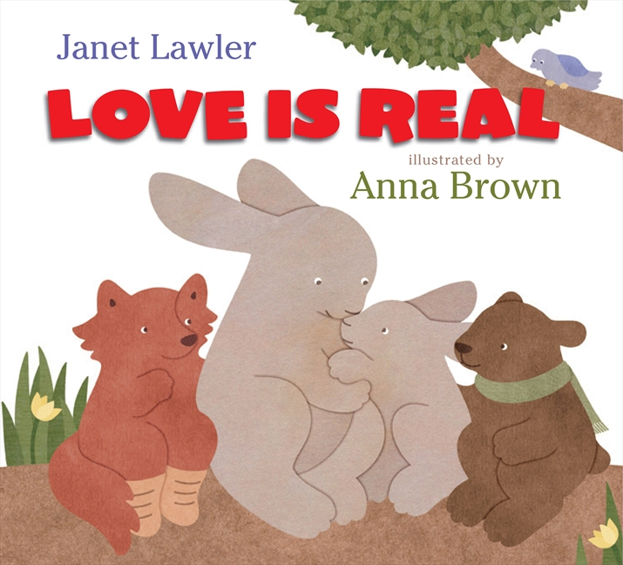

Discussion

- After reading LOVE IS REAL, ask child what actions they might take to show their love for a family member, a friend, or a pet.
- Use pages from book to show that sometimes parents show love for kids, kids show love for parents, and kids show love and care for each other.

Activity

- Create a card by folding plain card stock paper in half. On front of card, print or write the words: LOVE IS …
- Have child complete card, by drawing a picture on front and/or inside and
writing (if old enough) about how they show love for someone special.

