A Father’s Song
by Janet Lawler

Curriculum Guide

A father and child spend
a joyful day in the park.

PRE-READING DISCUSSION

Share the book cover. Read the title aloud. What do you think this book will be about? What do you think will happen in this story? Show back cover. Any more ideas?

QUESTIONS TO CONSIDER

How do dads show their love?
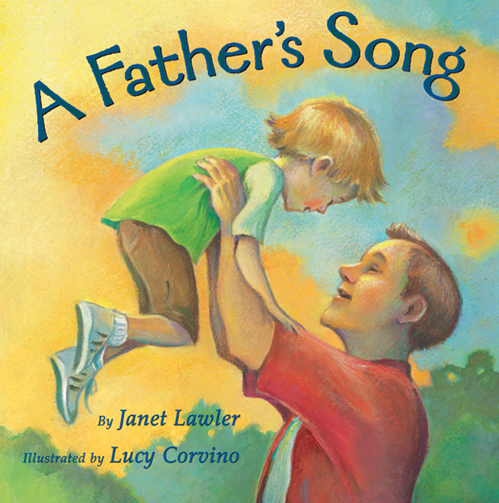
What fun things do you do with your dad (or maybe your step-dad, older brother, grandfather, uncle)?
Let’s see if any of those things are in this book.

DISCUSSION/PARTICIPATION WHILE READING TEXT
(consider one reading straight through, then discussing
page-by-page on 2nd reading)

Child on Shoulders
Do you remember riding on your dad’s shoulder’s like this?
How did that make you feel?
Could you see better?
Do you have sisters and brothers who still ride like that?
Do you wish you still could? Why?

Slide Ride

Do you like to go down slides?
What sound do you make if you “squeal with delight”?
Everyone close their eyes, pretend to be at top of slide.
Everyone ready? Now, squeal as you imagine zooming down.

Roar Like a Bear

Does your dad like making funny noises?
What animals does he pretend to be like?
Roar like a bear.
Growl a reply.
Everyone pick an animal and make a pretend noise.

Tears and Giggles

Does someone ever try to make you laugh when you are crying, or almost crying?
Why do you think they do that?
Does your dad make funny faces?
Does he make you laugh?

Father and Child Sharing Book

What book do you think they are reading?
What book do you like to read with your dad?
Read text again, pause to have everyone -
squeak like a mouse; bark like a hound (a hound is a dog.)

Airplane

Have you ever pretended you were an airplane?

Everyone stand. Carefully spread arms out and pretend you are an airplane. Make loops (turn in place if tight quarters).

Waves and Water

Do you like the beach?
Do you giggle and shout there?
What else do you do with dad at the beach?

Last page – Warm Embrace

Why do you think the child is asleep?
Why do you think the dad is smiling?
Do you ever fall asleep in someone’s arms at the end of a long day? or in the car?

QUESTION TO PONDER

Title

Why do you think the name of the book is A Father’s Song?
Is the dad happy in this book? Why?
Do you sing when you are happy?
Re-read 2nd to last page:

I can lift you and squeeze you
and fly all day long,
to bring on your laughter,
as sweet as a song.

Maybe the child’s laughter sounds like a song to the dad because he is so happy to be spending fun time with his child.

ART

Lucy Corvino is the illustrator of this book. That means she drew and painted all the pictures.
Do you like the colors she used?
How do the colors make you feel?
(If someone says they are sunny – How does the sun make you feel? Warm and good, inside and out.)

RELATED PROJECT

Make a Father’s Day card.

For older children: Write and illustrate a story about a special day or activity with Dad. (Consider making assignment more inclusive to encompass those without a dad.)

To learn more about the author and her other books visit: www.JanetLawler.com

